PSSI Science Project Reporting Template

️ | The PSSI Implementation Team is compiling a technical report to demonstrate the important research and advancements made by the Science Branch through the PSSI funding. The technical report will include a 3-4 page summary (including graphics and figures) for each project to show their key results and findings. Please fill in the following fields and sections for your project to be included in the report. Feel free to include and draw from any reports or presentations previously created through your research.  A plain language science bulletin will also be created to follow up on last year’s “DFO Pacific Region Science Bulletin, 2024. New research and monitoring for Pacific salmon and their ecosystems.” While the first bulletin introduced project backgrounds, methods, and timelines, this new bulletin will highlight the projects’ results, key findings, and conclusions with links to reports and data available. The bulletin will include a 1-2 page summary for each project gleaned from the content entered below.  ️ Completed forms are due January 7, 2026.  *Please include or send separately any graphics or pictures (with photo credits) that will help promote the projects.

PART 1: PROJECT METADATA

General Project Information
Project ID (number) | Project Title
2504 | Identifying and characterizing tire-related chemical (6PPD-quinone) toxic hotspots in salmon habitat
Project Leads | Collaborations and External Partners
Lisa Loseto (prev. T. Brown) | Dr. T. Brown, SFU  Dr. Rachel Scholes, Dr. Tim Rodgers, UBC  Dr. Edward Kolodziej  Tsawwassen First Nation  Tsleil-Waututh Nation  Musqueam Nation  Cowichan Tribes  Redd Fish Restoration  Vancouver Island University  BC Conservation Foundation  World Fisheries Trust  The Pacific Streamkeepers Federation  BC Ministry of Transportation  Somenos Marsh Wildlife Society
Location (if applicable)
Metro Vancouver
Squamish
Vancouver Island

Geographic and Stock Information
Salmon species (if applicable) | Waterbodies (if applicable)
All Pacific salmonids. | Watersheds in Southwestern B.C.
Life history phases (if applicable) | Region
Juvenile, Adults | Southwestern B.C.
Stock (if applicable) | Population (if applicable)
Hundreds | non-specific
Conservation Unit (if applicable)
non-specific

🧰 PART 2: PROJECT METRICS

Project Outputs
Include any anticipated outputs denoted as (in progress). Please include links to any outputs available online so they can be referenced in the report.
List scientific publications and technical reports (with links)
Liao, X., Ross, A.R. and Brown, T.M., 2025. An environmentally sensitive method for rapid monitoring of 6PPD-quinone in aqueous samples using solid phase extraction and direct sample introduction with liquid chromatography and tandem mass spectrometry. RSC Sustainability, 3(10), pp.4811-4817.

King, M.D., Rodgers, T.F.M., Sharma, G., Reger, S., Liao, X., Ross, A.R.S., Mueller, M., Drew, S., Scholes, R.C., Brown, T.M. 2025. Tracking 6PPD-Quinone dynamics in a coho salmon-bearing stream following rain reveals elevated concentrations for multihour periods during high flow. Environmental Science & Technology Letters. doi.org/10/1021/acs.estlett.5c00477

Rodgers, T.F.M., Drew, S., Brown, T.M., Hiki, K., Hiroshi, Y., King, M., Kolodziej, E.P., Krogh, E.T., McIntyre, J.K., Miller, K., Peng, H., Tomlin, H., Wang, Y., Scholes, R.C. 2025. Turning the corner on hazardous tire compounds: A management framework for tire additive pollution. Environmental Science & Technology Letters. doi.org/10.1021/acs.estlett.5c00453

Ross, A., Liao, X., Brown, T.M. 2023. Simultaneous determination of steroid hormones and pharmaceuticals in killer whale (Orcinus orca) fecal samples by liquid chromatography-tandem mass spectrometry. Analytical and Bioanalytical Chemistry. Conservation Physiology. doi.org/10.1093/conphys/coad081
​
Monaghan, J., Jaeger, A., Jai, J.K., Tomlin, H., Atkinson, J.B., Brown, T.M., Gill, C., Krogh, E. 2023. Automated, high-throughput analysis of tire-derived p-Phenylenediamine Quinones (PPDQs) in water by online membrane sampling coupled to MS/MS. ES&T Water. 3(10): 3293-3304 doi.org/10.1021/acsestwater.3c00275

List datasets generated (with links)
Click or tap here to enter text.
Describe dataset locations and data management systems
Using MS Excel Spreadsheets (saved on MS Teams, SFU and DFO drives, including OneDrive)

List code, programs, or other software created (with links)
Click or tap here to enter text.
List communication or social media products
Brown, T.M., Reger, S., Lioa, X., Gallilee, C. 2023. Identifying and characterizing tire-related chemical (6PPD-quinone) toxic hotspots in salmon habitat in British Columbia, Canada. Canadian Ecotoxicology Workshop, Ottawa, ON, October 5, 2023.

Brown, T.M. 2024. The tire associated chemical 6PPD-quinone and the risks it poses to coho salmon. Coho Salmon Festival, West Vancouver, September 8, 2024.

Hassan Aghaei, M., Brown, T.M. 6PPD-quinone underscores the risks of nonpoint source pollution in Pacific salmon habitat. Lunch and Learn, District of North Vancouver, September 11, 2024.

Brown, T.M., Scholes, R. 2024. Identifying and mitigating hotspots of salmon exposure to toxic road runoff. Protecting Salmon from Tire Wear Toxins – 6-PPDQ Workshop. Nanaimo, April 29, 2024.

Brown, T.M., King, M.D., Colbourne, K., Drew, S., Gallilee, C., Hassan Aghaei, M., Joy, R., King, M.D., Kolodziej, E., Lai, D., Liao, X., Loseto, L., Mueller, M., Reger, S., Rodgers, T.F.M., Ross, A., Scholes, R.C., Sharma, G. 2025. The timing, magnitude, and extent of 6PPD-Q pulses in salmon streams during wet weather. Protecting Salmon from Tire Wear Toxicants, 6PPDQ Workshop, May 9, 2025.

Brown, T., King, M. 2024. The tire associated chemical 6PPD-quinone and the risks it poses to coho salmon. SFU BISC 171 course guest lecture hosted by Dr. Tony Williams. Burnaby, British Columbia.

Brown, T.M., Colbourne, K., Drew, S., Gallilee, C., Hassan Aghaei, M., Joy, R., King, M.D., Kolodziej, E., Lai, D., Liao, X., Loseto, L., Mueller, M., Reger, S., Rodgers, T.F.M., Ross, A., Scholes, R.C., Sharma, G. 2025. What levels of 6PPD-Q are we seeing in Southwest British Columbia creeks, where are the hotspots. 6PPD-Quinone Workshop, Pacific Science Enterprise Centre, West Vancouver, September 19, 2025.

Brown, T.M., Colbourne, K., Drew, S., Gallilee, C., Hassan Aghaei, M., Joy, R., King, M.D., Kolodziej, E., Lai, D., Liao, X., Loseto, L., Mueller, M., Reger, S., Rodgers, T.F.M., Ross, A., Scholes, R.C., Sharma, G. 2025. Characterizing 6PPD-Q concentrations and hotspots in salmon-bearing creeks in Southwest B.C. State of Washington Department of Ecology 6PPD State of the Science Forum. Virtual workshop.

King, M. 2025. How does 6PPD-quinone affect salmon? Species sensitivity and toxicology. Fisheries and Oceans Canada 6PPD-Q “Toxic Tire Chemical” Workshop. West Vancouver, British Columbia.

King, M., Brown, T., Rodgers, T., Scholes, R., Sharma, G., Drew, S., Liao, X., Ross, A., Mueller, M., Richards, A., & Ouellet, F. 2025. Time series 6PPD-Q concentrations in urban salmon streams. State of Washington Department of Ecology 6PPD State of the Science Forum. Virtual workshop.

King, M., Rodgers, T., Sharma, G., Reger, S., Liao, X., Ross, A., Mueller, M., Moloney, K., Drew, S., Scholes, R., Brown, T. 2024. Tracking 6PPD-Q concentration dynamics in coho salmon-bearing streams following rain events. Society of Environmental Toxicology and Chemistry North America 45th Annual Meeting. Fort Worth, Texas.

King, M., Rodgers, T., Sharma, G., Reger, S., Scholes, R., Liao, X., Ross, A., Brown, T. 2024. 6PPD-Q concentrations in coho salmon stream water during rain events. Protecting Salmon from Tire Wear Toxins 6-PPDQ Workshop 2024. Nanaimo, British Columbia.

List and describe field work completed
Monitoring of 6PPD-Q concentrations in salmon bearing streams: Field work was carried out from ‘before’, ‘during’, and ‘after’ wet weather events from April 1 2023 to January 31, 2026 at 64 new sites in salmon bearing streams located across Metro Vancouver and Vancouver Island. This work builds on past funded work through CSRF which characterized 6PPD-Q concentrations in 34 sites located in Metro Vancouver, Squamish and Vancouver Island.

Temporal studies of 6PPD-Q concentrations in salmon bearing streams:
To determine the concentrations of 6PPD-quinone in urban salmon streams over relevant timescales and dynamic flow conditions, several mutually supportive datasets were generated over the 2023-2025 period.
- Teledyne ISCO portable autosampler lab and field validation samples
- Triplicate baseline, first flush, and storm flow time series generated at five sites, samples for TSS, metals, and 6PPD-quinone analysis using Teledyne ISCO portable autosamplers
- Paired stage-flow measurements collected to model five hydrological rating curves
- Collated rain and flow data from municipal instruments, plus supporting rain data with our own portable gauge
- Nine multiparameter sonde time series

Effectiveness of in-use raingardens:
- Samples were collected during two rain events (November 13. 2025 and January 28. 2026) from the rain garden located in North Vancouver (Londsale Ave. and 21 St.).
- Samples were collected during rain events at the McKenzie Interchange, Victoria from both direct highway runoff and the bioswale effluent.

List and describe samples collected/analyzed (number of samples)
Monitoring of 6PPD-Q concentrations in salmon bearing streams:
- A total of 1,485 samples were collected and analyzed for 6PPD-Q at SGS AXYS Analytical Ltd, Institute of Ocean Sciences, DFO, and BCIT.

Temporal studies of 6PPD-Q concentrations in salmon bearing streams:
- A total of 633 field-collected stream water samples and 54 laboratory methods development and validation test water samples were analyzed for 6PPD-Q at DFO and BCIT.

Effectiveness of in-use raingardens:
- In one model rain garden, five samples were analyzed for 6PPD-Q from the influent, multiple ponding locations, and the effluent for two rain events.
- During 6 rain events, a total of 12 samples from the McKenzie Interchange and McKenzie bioswale effluent were analyzed for 6PPD-Q.
- Samples will provide a first-look at rain garden influent and effluent concentrations and thereby facilitate load and target reduction estimates.

List and describe large capital assets or equipment acquired
No equipment or large capital assets were acquired.

PART 3: WRITTEN CONTENT

Highlights
Please summarize in 2-3 bullets:
- The main idea of the project
- Key findings
- Implications of these findings for salmon and decision-makers
- For a more technical audience, but still as plain language as possible
Our projects overall goals were to characterize 6PPD-quinone (6PPD-Q) concentrations before, during, and after wet weather events, develop a predictive hot spot map using the measured 6PPD-Q values in combination with land use, traffic density, and weather data, and assess the effectiveness of in-use raingardens at removing 6PPD-Q. This project builds on our earlier 6PPD-Q field program which characterized the presence 6PP-Q at 34 sites in salmon bearing creeks in the greater Vancouver area, Squamish and Vancouver Island before, during, and after rain events. The sample collection has been carried out with help from several ENGOs, First Nations, and University partners. Key findings include:
- 78% of the sites monitored during wet weather events have concentrations that exceed lethal threshold values for coho salmon.
- Positive associations were observed between 6PPD-Q and residential cover and commercial cover, as well as environmental data including turbidity and the number of dry days prior to flow.
- Water sample 6PPD-Q concentrations during rain events were strongly correlated with copper and zinc, all of which were found to exceed water quality guidelines in urban and semi-urban areas.
- Temporal monitoring indicated that during baseflow conditions, concentrations never exceeded water quality guidelines, but following any sustained rainfall streams failed water quality guidelines and usually surpassed published toxicity thresholds published for juvenile coho salmon and coastal cutthroat trout. Every monitoring period saw multi-hour periods (e.g. 4-19 hours) of 6PPD-Q which exceeded lethal thresholds for coho salmon. Collectively, this suggests a widespread toxicity hazard exists for coho salmon and related salmonid taxa in urban streams.

This project has delivered new data on 6PPD-Q levels in salmon bearing creeks in coastal British Columbia and is being used in the reassessment of 6PPDQ, the parent compound of 6PPD-Q, under the Canadian Environmental Protections Act (CEPA). This study is providing information to PSSI and fisheries managers as they aim to curb historic declines in Pacific salmon, particularly coho salmon which are highly sensitive to this chemical and enable their recovery.

Background
Please provide 1-2 paragraphs to summarize
- The relevant biological, environmental, and/or management context
- What knowledge gap or demand were you trying to fill?
- Collaboration and partner relationships
Pacific salmon are a foundational group of species in the Northeastern Pacific Ocean that rely on freshwater habitats along the west coasts of British Columbia (Canada) and the states of Alaska, Washington, Oregon and California (USA). Pacific salmon play a vital role in supporting wildlife, including pinnipeds, killer whales, bears, and seabirds, and serve as a valued source of food for coastal communities and Indigenous Nations.

Many salmon populations, however, have experienced significant declines in recent decades [1] due to climate change, habitat degradation, overexploitation, and diseases [2-4]. Habitat degradation in particular has resulted in the loss of reproductive potential in freshwater ecosystems, with forestry, agriculture, and urban developments altering the nature of physical environments and resulting in the release of pollutants into waterways.

Urban stormwater runoff from roads, parking lots and other impervious surfaces is now recognized as a major nonpoint source of pollution to salmon-bearing streams. Wet weather events mobilize complex mixtures of contaminants, including tire wear particles, p-phenylenediamines (PPDs), polycyclic aromatic hydrocarbons (PAHs), metals, salts, and current-use pesticides that lead to pulses of pollutant releases into salmon habitats [5-7]. Urban Runoff Mortality Syndrome (URMS) is known to cause mortality in adult coho salmon (Oncorhynchus kisutch) returning to urban and semi-urban waterways in Puget Sound, Washington State [8]. This syndrome has more recently been attributed to the tire-associated chemical N-(1,3-Dimethylbutyl)-N'-phenyl-p-phenylenediamine-quinone (6PPD-Q), which has been found to be the cause of toxic injury and death (40-90%) of adult coho salmon returning to urban and semi-urban waterways in Puget Sound.

At the start of the study, little data had been generated on 6PPD-Q concentrations in salmon bearing streams along the northwest coast of North America, no studies had carried out a temporal assessment of 6PPD-Q concentrations during wet weather events, and only one study had assessed the effectiveness of removal of 6PPD-Q in a raingarden. This study was aimed to help fill these gaps by achieving the following:
- Provide new data on 6PPD-Q concentrations in salmon bearing habitat
- Characterize risk of exposure and lethality to coho salmon as well as other Pacific salmon species in the region
- Incorporate our data into stormwater runoff modeling with our partners at UBC to be used in combination with weather, traffic data and flow measurements, or estimates, to identify high-priority areas for monitoring or green infrastructure initiatives
- Complete a hotspot map for salmon bearing streams in the Lower Mainland, Squamish, and Vancouver Island using our data combined, land use variables, statistical modeling, and GIS.

️ Methods and Findings
Please insert a few paragraphs to summarize:
- Main methods used
- Products and tools produced
- Advancements in methodology, technology, and application
- Advancements in communication and knowledge transfer
- Key results and information generated
Field collections: A total of 2,118 stream water samples from salmon bearing streams, 27 road runoff samples, and 54 laboratory methods development and validation test water samples were collected and analyzed for 6PPD-Q.

Analytical Methods: 6PPD-Q in unfiltered water samples was quantified using liquid chromatography-tandem mass spectrometry (LC-MS/MS) with an Agilent 1290 Infinity II UPLC system and a Sciex triple-quadrupole API5000 mass spectrometer equipped with a Turbo V Ion source. Water samples spiked with an internal standard (99% phenyl 13C6 6PPD-Q, ACP Chemical Inc.) were analyzed either directly after dilution or after solid-phase extraction.

Key Findings:
- 78% of the sites monitored during wet weather events have concentrations that exceed LC50 values for coho salmon (Lethal Concentration at which 50% of a test population dies).
- Continual temporal monitoring revealed that 6PPD-Q concentrations exceeded the LC50 reported for juvenile coho salmon by up to 6-fold, with exceedances lasting from 4 to 19 hours during rain events
- Salmon habitat in urban and semi urban areas across southern B.C. is subject to repeated pulses of 6PPD-Q, as well as other toxic chemicals (e.g., copper and zinc) over the course of the wet season that expose coho salmon to toxic concentrations for considerable periods.

Insights
Please insert a few paragraphs to summarize:
- What this project has added to knowledge about salmon populations, health, or ecosystems.
- How this project informs salmon management:
  - decisions
  - policy guidance
  - trade-offs
  - planning
- Addition of knowledge to understanding:
  - limiting factors/stressors/threats/ pathways of effects/risks
  - biologically significant thresholds
  - cumulative impacts
- Sources of uncertainty
We have characterized 6PPD-Q contaminant concentrations and risks in nearly 100 salmon bearing creeks in southern British Columbia. Our results indicate a high risk of lethality for coho salmon and coastal cutthroat trout during wet weather events in streams located in semi-urban and urban areas.
Management questions addressed by this project include those related to understanding and mitigating an identified stressor (i.e., 6PPD-Q) on at-risk salmon species and populations.
The findings from our project will directly inform regulatory risk assessments, as well as cumulative risk assessments led by resource managers, as well as other organizations, which will explicitly consider the combined fate and effects of a myriad of stressors for salmon (i.e. contaminants, climate change, habitat destruction, overharvesting, etc.). These findings will also enable a comprehensive understanding of the contribution that 6PPD-Q directly plays in the population level declines of coho salmon, as well as indirectly for other pacific salmonids, and key predators (e.g., at-risk Resident killer whales).
This cumulative information will be incorporated into developing recommendations for measures that will address contaminants affecting salmon and their habitat. In addition, it will inform coho salmon recovery plans for COSEWIC- and ESA-listed populations. Ultimately, decisions that regulate the release of 6PPD-Q and other priority contaminants of concern to salmon and other aquatic coastal wildlife can then be considered for source control, reduction or elimination measures.

⏩ Next Steps
Please insert 1-2 paragraphs to summarize:
- Remaining knowledge gaps and recommendations for future studies
- How can/should the project findings be operationalized for salmon conservation and management?
- Completion of the predictive hot spot map for 6PPD-Q is underway and will be completed prior to March 31, 2026. This map will aid in identifying priority areas for monitoring this toxic chemical as well as identifying priority areas for the installation of environmental engineering initiatives.
- This information will be used to enable regional authorities (e.g. Metro Vancouver) and municipalities to make informed decisions around effective mitigation strategies on non-point source releases into high priority areas. This will have a positive effect as the findings will inform on road runoff discharges of contaminants into the habitat of hundreds, if not thousands of distinct salmonid populations, including coho, Chinook, sockeye, chum, pink, steelhead trout, and coastal cutthroat trout. Even more broadly, this information is likely to be relevant to potential road runoff exposure and associated impacts that other aquatic species may be experiencing both nationally and internationally in urban watersheds.
- At least five additional rain garden sites will be selected, aiming for a minimum of three rain event sample collection per site. In addition, soil microbial communities will be evaluated across the selected rain garden sites.

📈 Tables and Figures
Please provide captions and numbering for any tables and figures. Graphics can be copied below or e-mailed separately.
- Include a brief caption with each figure and table in the box below
- Number each table and figure, and include references in the above sections where appropriate.
- 1-3 figures are recommended per project
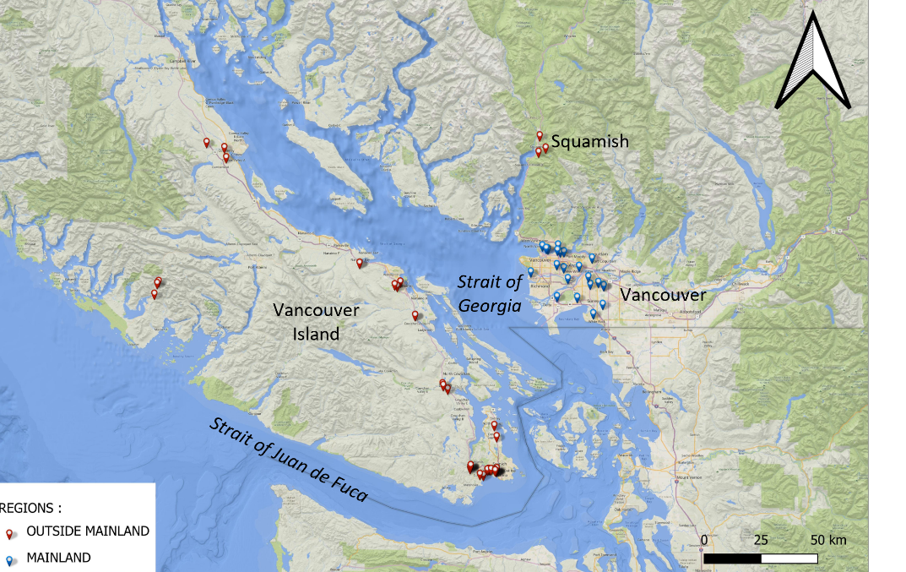
Figure 1. Map of 6PPD-Q monitoring sites (n=98) in salmon-bearing streams in southern British Columbia.

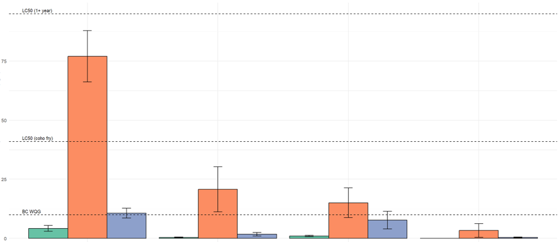
Figure 2. Average 6PPD-Q concentrations in our field samples in urban and semi-urban areas exceed screening values (water quality guidelines) and lethal concentrations for coho salmon.

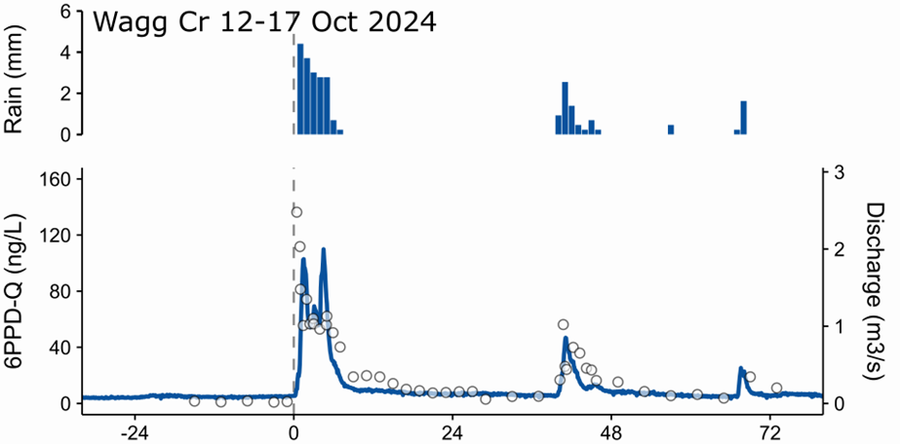
Figure 3. Time series data of rain (top panel), stream discharge (right axis), and 6PPD-quinone concentration (left axis) at Wagg Creek from October 12-17 2024. This type of time series data was obtained and represents the core data of the temporal 6PPD-quinone monitoring research.

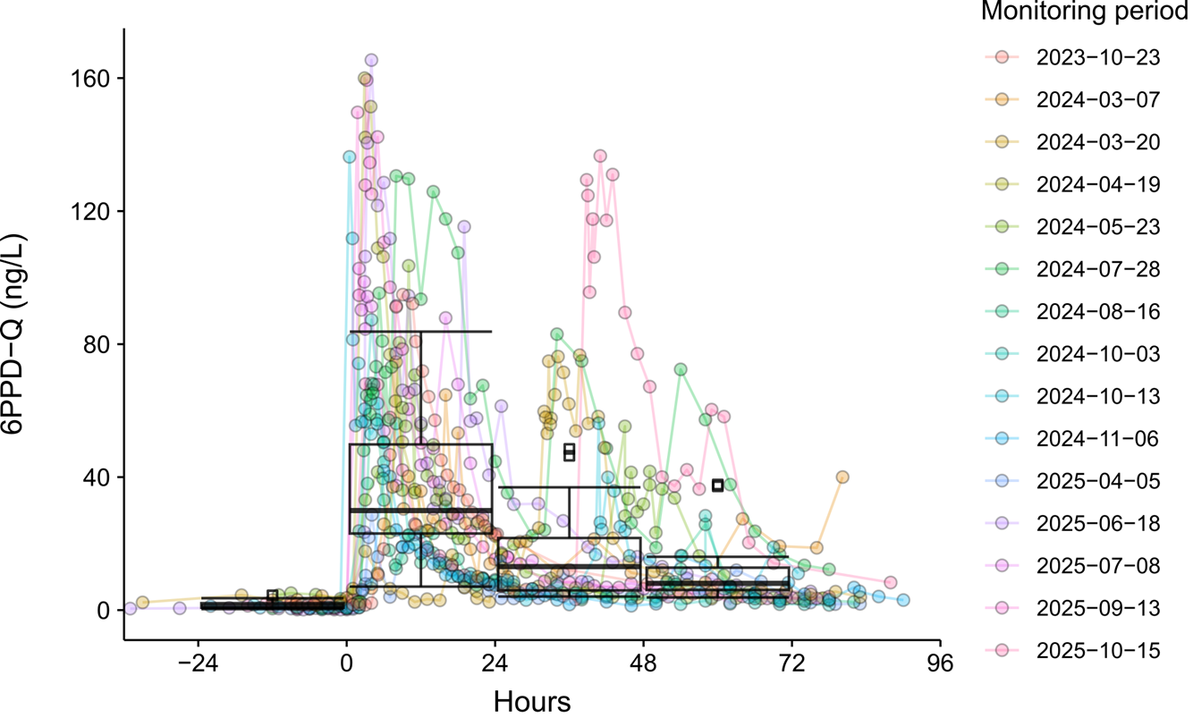Figure 4. Time series data from temporal 6PPD-quinone monitoring research. Time-harmonized data indicate that, averaged over 24-hour periods, the initial flushing period yields the highest time-averaged concentrations, significantly higher than during the preceding dry weather.

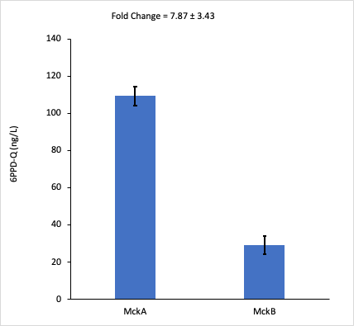

Figure 5. 6PPD-Q concentration at McKenzie Interchange road runoff (MckA) and the bioswale effluent (MckB) for 6 rain events. The graph indicates approximately 7-fold reduction of 6PPD-Q in bioswale effluent compared to the road runoff.

📈 References
Include full references for any publications referenced in other sections. Please format references in Harvard style according to Instructions to Authors for the Canadian Journal of Fisheries and Aquatic Sciences, at Canadian Science Publishing.
1. Grant, S.C.H., B.L. MacDonald, and M.L. Winston, State of Canadian Pacific Salmon: Responses to Changing Climate and Habitats, in Canadian Technical Report of Fisheries and Aquatic Sciences. 2019, Fisheries and Oceans Canada: Nanaimo, B.C. p. 50.
2. Levin, P., R. Zabel, and J. Williams, The road to extinction is paved with good intentions: negative association of fish hatcheries with threatened salmon. Proceedings of the Royal Society B: Biological Sciences, 2001. 268: p. 1153-8.
3. Miller, K.M., et al., Infectious disease, shifting climates, and opportunistic predators: cumulative factors potentially impacting wild salmon declines. Evolutionary Applications, 2014. 7: p. 812-55.
4. Bass, A.L., et al., Identification of infectious agents in early marine Chinook and Coho salmon associated with cohort survival. Facets, 2022. 7.
5. Hill, M.J., et al., Pond sediments reveal the increasing importance of road runoff as a source of metal contaminations in industrialized urban environments downwind of Pittsburgh, Pennsylvania (USA). Environmental Science and Technology Water, 2023. 3: p. 650-658.
6. Zhang, K., et al., Review of trace organic chemicals in urban stormwater: Concentrations, distributions, risks and drivers. Water Research, 2024. 258: p. 121782.
7. King, M.D., et al., Tracking 6PPD-Quinone dynamics in a coho salmon-bearing stream following rain reveals elevated concentrations for multihour periods during high flow. Environmental Science and Technology Letters, 2025. 12: p. 1026-1031.
8. Scholz, N.L., et al., Recurrent die-offs of adult coho salmon returning to spawn in Puget Sound lowland urban streams. PLoS One, 2011. 6(12): p. e28013.

